RESPONSIVE
LANDING PAGE
Student Name: M.Shehana Safreen
Register / Roll Number:244002
Department / Institution: CSE/K.L.N College of Engineering

Abstract
This project focuses on the design and implementation of a modern, responsive landing page for a fictional productivity workspace brand named Northstar. The website communicates a clear product value proposition and guides visitors through features, a simple workflow, a testimonial-style statement, and a final call to action. The interface uses semantic HTML5 for structure, CSS Flexbox and Grid for layout, and media queries to adapt the experience to different screen sizes. Vanilla JavaScript powers the mobile navigation menu and updates the footer year dynamically. Accessibility considerations include a skip link, descriptive navigation labels, ARIA attributes for the menu button, and meaningful page landmarks. The deliverable contains the HTML, CSS, JavaScript, a wireframe description and preview, and project documentation. The report documents the objectives, requirements, design process, implementation, testing approach, limitations, and future enhancements.

Table of Contents
- 1. Introduction
- 2. Problem Statement
- 3. Objectives and Scope
- 4. Requirements Analysis
- 5. Tools and Technologies
- 6. System Design and Wireframe
- 7. User Interface and Page Structure
- 8. Implementation Details
- 9. Responsive Design Strategy
- 10. Accessibility and Usability

1. Introduction
A landing page is a focused web page designed to introduce a product, service, event, or organization and encourage visitors to take a clear next step. An effective landing page combines readable content, visual hierarchy, simple navigation, responsive layout, and clear calls to action.
The Northstar project presents a fictional digital workspace that helps teams organize projects, priorities, and collaboration in one place. The page was designed as a polished marketing concept with a calm visual style, concise copy, feature cards, a step-by-step explanation, and a closing call to action. It is a static front-end prototype and does not connect to a backend service.

2. Problem Statement
Create a professional landing page from a wireframe that works across desktop, tablet, and mobile screens. The page must include a header and navigation, hero section, feature highlights, footer, semantic HTML5, CSS Flexbox/Grid, media queries, and a responsive navigation toggle implemented with vanilla JavaScript. The code should be organized and commented where useful, and the interface should be checked at multiple viewport sizes.

3. Objectives and Scope

3.1 Objectives
- Translate a wireframe concept into a visually consistent web page.
- Use semantic HTML5 elements to create a meaningful document structure.
- Use CSS Grid and Flexbox to create flexible, maintainable layouts.
- Apply responsive breakpoints so the design adapts to different screen widths.
- Build a mobile navigation toggle with vanilla JavaScript and accessible state attributes.
- Use a consistent visual system for typography, spacing, color, cards, and buttons.
- Document project files and define a practical manual testing checklist.

3.2 Scope
The project includes the front-end presentation layer only. It includes navigation between page sections, responsive styling, a CSS-built dashboard illustration, feature cards, a process section, a quote panel, and a demo contact call to action. It does not include user authentication, database storage, payment processing, a real product dashboard, analytics, or a live contact form.

4. Requirements Analysis

4.1 Functional Requirements
- The brand link returns visitors to the top of the page.
- Navigation links move to Features, How it works, Stories, and Get started sections.
- The hero section introduces the product concept and provides primary and secondary actions.
- Feature cards communicate three product benefits.
- The how-it-works section presents a three-step workflow.
- The mobile menu button opens and closes the navigation on smaller screens.
- The menu button exposes its state through aria-expanded and an accessible label.
- The menu closes after a navigation link is selected.
- The footer year is generated dynamically by JavaScript.

4.2 Non-Functional Requirements
- Responsive behavior across desktop, tablet, and mobile viewport sizes.
- Readable typography and sufficient spacing for comfortable scanning.
- Semantic page landmarks and keyboard-friendly navigation patterns.
- Maintainable separation of HTML, CSS, and JavaScript.
- Fast loading without a front-end framework or external JavaScript dependency.
- Consistent visual hierarchy and reusable styling conventions.

5. Tools and Technologies
- HTML5: semantic page structure, links, buttons, headings, and content sections.
- CSS3: visual styling, spacing, colors, typography, cards, transitions, Flexbox, Grid, and media queries.
- Vanilla JavaScript: responsive menu state, ARIA updates, menu dismissal, resize handling, and dynamic footer year.
- Code editor: any text editor or IDE capable of editing HTML, CSS, and JavaScript.
- Web browser: local preview and manual responsive checks using browser resizing or developer tools.
No framework is required to run the prototype. The page can be opened locally by launching index.html in a modern browser. A local development server may also be used for a more realistic workflow.

6. System Design and Wireframe
The design process begins with the page’s information hierarchy. The visitor first sees the brand and navigation, then the product promise and primary call to action. Supporting sections explain the benefits, describe the workflow, reinforce the message, and finish with a final action.

6.1 Wireframe Sections
- Header: brand mark on the left and section navigation on the right; a menu button is used on small screens.
- Hero: short eyebrow label, prominent headline, supporting paragraph, two actions, social-proof text, and a dashboard illustration.
- Feature highlights: three cards describing organization, visible progress, and collaboration.
- How it works: explanatory copy paired with three numbered steps.
- Stories / quote: a prominent brand statement in a contrasting panel.
- Call to action: closing headline, supporting copy, and demo contact link.
- Footer: compact closing information and dynamically updated year where provided in the implementation.

6.2 Wireframe Preview
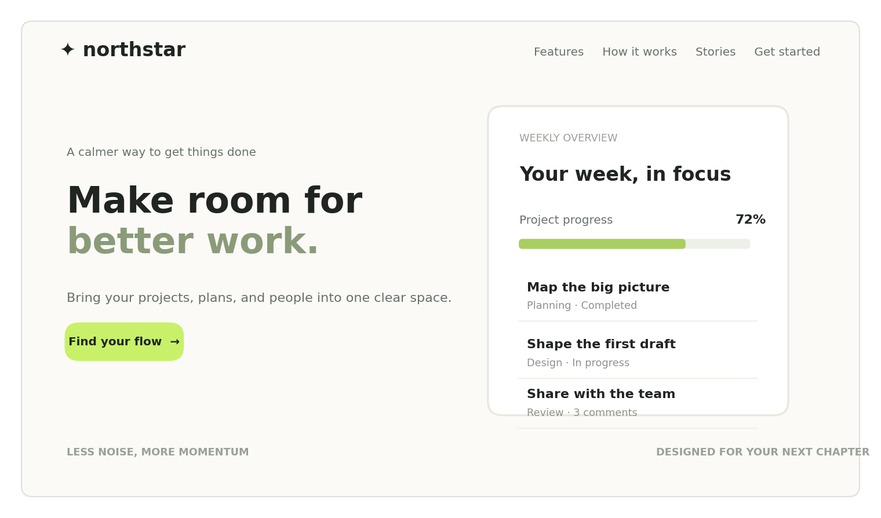
Figure 1. Wireframe / layout preview supplied with the project files.

6.3 Visual Design Principles
- Visual hierarchy: a large hero headline draws attention before supporting details.
- Whitespace: generous spacing separates sections and improves scanning.
- Color system: muted neutral backgrounds are paired with restrained accent colors.
- Reusable components: buttons, cards, section headings, and containers share consistent styles.
- Illustration: the dashboard visual is composed with HTML and CSS, reducing the need for external image assets.

7. User Interface and Page Structure

7.1 Header and Navigation
The header contains the Northstar brand link and a navigation region. A semantic nav element and descriptive label identify the primary navigation. On compact screens, a button with aria-controls and aria-expanded identifies the menu it controls and reports whether it is open.

7.2 Hero Section
The hero introduces Northstar with the message “Make room for better work.” It combines a short description with a primary action and a secondary link. The adjacent CSS-built dashboard illustration gives the visitor a visual impression of the product without requiring a real application backend.

7.3 Feature Cards
Three feature cards describe the concept through distinct themes: keeping work connected, making progress visible, and collaborating as a team. Each card uses a title, short explanatory copy, a link, and a small decorative visual.

7.4 Process Section
The process section reduces the product story to three steps: bring work together, choose the next action, and review progress. The numbered layout makes the sequence easy to scan.

7.5 Quote and Call to Action
The quote panel adds a memorable statement, while the final call-to-action section gives the visitor a clear next step. The contact action is a demonstration mailto link using hello@example.com, so it should be replaced with the intended contact address before a real deployment.

8. Implementation Details

8.1 HTML Structure
The HTML document declares the document type, language, character encoding, viewport metadata, page title, and a short meta description. The stylesheet and JavaScript are stored in separate files. The JavaScript file uses the defer attribute so it can run after the HTML has been parsed.
<!doctype html>
<html lang="en">
<head>
<meta charset="utf-8">
<meta name="viewport" content="width=device-width, initial-scale=1">
<meta name="description" content="A responsive landing page concept for a modern digital workspace.">
<title>Northstar | Make room for better work</title>
<link rel="stylesheet" href="styles.css">
<script src="script.js" defer></script>
</head>
<body>
<a class="skip-link" href="#main">Skip to content</a>
<header class="site-header">...</header>
<main id="main">...</main>
<footer>...</footer>
</body>
</html>

8.2 CSS Layout
CSS custom properties and reusable classes help keep the visual system consistent. Flexbox is suitable for one-dimensional alignment, such as navigation and button groups. CSS Grid is used for multi-column sections such as the hero and feature cards. Media queries adjust column counts, spacing, and navigation behavior at smaller widths.
.container {
width: min(100% - 2rem, 72rem);
margin-inline: auto;
}

.hero-grid {
display: grid;
grid-template-columns: minmax(0, 1fr) minmax(0, 1fr);
gap: clamp(2rem, 5vw, 5rem);
align-items: center;
}

/* Representative responsive pattern */
@media (max-width: 760px) {
.hero-grid {
grid-template-columns: 1fr;
}
}

8.3 JavaScript Behavior
The script selects the menu button and navigation element, toggles the menu’s open state, updates aria-expanded and the accessible label, closes the menu after a link is activated, and resets the state when the viewport returns to a desktop layout. It also writes the current year into the footer element when that element is present.
// Small, accessible interactions: mobile navigation and current footer year.
const menuToggle = document.querySelector(".menu-toggle");
const primaryNavigation = document.querySelector("#primary-navigation");

if (menuToggle && primaryNavigation) {
menuToggle.addEventListener("click", () => {
const isOpen = menuToggle.getAttribute("aria-expanded") === "true";
menuToggle.setAttribute("aria-expanded", String(!isOpen));
menuToggle.setAttribute("aria-label", isOpen ? "Open navigation menu" : "Close navigation menu");
primaryNavigation.classList.toggle("is-open", !isOpen);
});

// Close the mobile menu after a navigation link is selected.
primaryNavigation.querySelectorAll("a").forEach((link) => {
link.addEventListener("click", () => {
menuToggle.setAttribute("aria-expanded", "false");
menuToggle.setAttribute("aria-label", "Open navigation menu");
primaryNavigation.classList.remove("is-open");
});
});

// Restore the desktop navigation state when resizing above the mobile breakpoint.
window.addEventListener("resize", () => {
if (window.innerWidth > 680) {
menuToggle.setAttribute("aria-expanded", "false");
menuToggle.setAttribute("aria-label", "Open navigation menu");
primaryNavigation.classList.remove("is-open");
}
});
}

const year = document.querySelector("#year");
if (year) year.textContent = new Date().getFullYear();

8.4 File Separation
The HTML contains content and semantic structure, the CSS controls presentation and responsive behavior, and JavaScript handles interactive state. This separation makes the project easier to understand, test, and extend.

9. Responsive Design Strategy
Responsive design ensures that the content remains usable when the viewport changes. The project uses a fluid container, flexible grid columns, and media queries. At wider widths, the hero and feature content can sit side by side. At narrower widths, content stacks vertically, spacing is adjusted, and navigation changes to a menu-toggle interaction.
- Desktop: multi-column hero and feature layout; navigation displayed horizontally.
- Tablet: narrower gutters and columns adapt to the available width; text remains readable.
- Mobile: sections stack vertically; menu button controls the primary navigation; buttons and content are given adequate space.
- Viewport metadata: ensures the layout uses the device’s actual viewport width.
- Fluid spacing: CSS clamp() and flexible sizing can smooth changes between common breakpoints.

10. Accessibility and Usability
- Semantic landmarks: header, nav, main, section, article, and footer elements clarify the page structure.
- Skip link: allows keyboard users to jump directly to the main content.
- Navigation label: the nav element has a descriptive accessible name.
- Menu state: aria-expanded communicates whether the responsive menu is open.
- Controlled element: aria-controls connects the menu button to the navigation region.
- Descriptive links: selected links have labels that explain their destination or purpose.
- Visual clarity: consistent headings, spacing, and contrast support readability.

